ICT80004 – Internship Project

  - Student Name : Arun Ragavendhar Arunachalam Palaniyappan

  - Student ID : 104837257

Self-Assessment
Self-Assessment Details
The following checklists provide an overview of my self-assessment for this unit.

Self-Assessment (please rate yourself) | Provide your most outstanding achievements that you achieved for each learning outcome | Mark  0 – 20 for each LO
LO1: Improve your awareness of a range of issues associated with professional practice | I setup a clear reporting and evidence system (agendas, risks/decisions, reproducible logs) that kept CSIRO client requirements and Swinburne internship requirements in an aligned way. | 19
LO2: Further develop professional and personal skill | I turned my supervisor’s feedback by doing shorter and tighter live demos, presentations and plain-English slides; delivered all my tasks on time, every week, for 12 weeks and sent the weekly updates and communication mails for each week. | 18
LO3: Apply your practical skills and theoretical knowledge into an IT industry context | I Built an end-to-end LLM security test suite (text attacks, code attacks, and Familiar Pattern Attacks), a single-file CWE-121 demo with ASan/UBSan, and an R validation script that others can re-run, as I made it open-source. All of these help a common user to use AI in a safer way without getting harmed or scammed. | 19
LO4: Develop your understanding of business processes and organisational structures | I planned, coordinated and presented my mid and final reviews with agendas, roles, and follow-ups with my academic and industry supervisors, connecting my work to CSIRO’s project delivery schedule and expectations. | 19
LO5: Develop professional contacts and networks within the IT industry | I built strong ties at CSIRO through regular check-ins and cross-team introductions, and earned a LinkedIn recommendation from Dr. Shigang Liu, with excellent feedback on my technical skills as well as my soft skills. | 19
 | Total | 94/100

Self-Assessment Checklist
Assessment | Completed (please tick)
Completed Learning Summary Report (This report) | Yes
Submitted at least 10 weekly communications to the industry supervisor | Yes
Completed 5 reflections (quizzes) | Yes
Completed 3 (pre, mid and final) internship project reviews | Yes
Completed the internship project video report | Yes
Presented internship work completed during the final presentation | Yes
Completed the Internship Role Video Consent and Release Form | Yes

Professional Practice | Response
Did you answered ‘Yes’ to attending lectures during the interview? | Yes
How many times did you attend the lecture? | 9
How many lecture recordings have you viewed if you cannot attend? | 3 (I viewed all the recordings that I missed due to some unavoidable commitment).
Did you attempt to schedule a visit on an unavailable as posted on Canvas? | No
How many opportunities did you took up from the announcement? | 3 (Adobe Express Workshop, Stepping into Industry (Linda Mork) and Guest Speaker – Hansi Nissanka).
How many internship agreements did you sign this semester? | 1 Internship agreement (with CSIRO as the client. Signed 2 documents, one between Swinburne and CSIRO and one at CSIRO just before joining).

Declaration
I declare that this portfolio is my individual work including the above self-assessment. All responses are correct, and I have not copied from any other student’s work or from any other source except where due acknowledgment is made explicitly in the text, nor has any part of this submission been written for me by another person.

Signature:
Project Experience Report

Introduction
This report summarises what I learnt in ICT80004 – Internship Project. It includes a self-assessment against the criteria described in the unit outline, a justification of the participations included, details of the coverage of the unit’s intended learning outcomes, and a reflection on my learning.

Reflection on the Participations in Internship Project
This section summarises the participations based on specific instances starting from securing an internship role to during the internship period.
- Internship Role (LO1, LO2 and LO5). Before the start of the semester
  - Complete the table below. List the roles and organisations that applied for.

Name of organisation applied | What is the role? | Got interview from the organisation (Y/N) | Got offer from the organisation (Y/N) | Signed agreement (Y/N) | Knew someone in the organisation (Y/N)
CSIRO (Data61) | ML/AI Engineer & Software Developer Intern | Yes | Yes | Yes | No
Focus Bear | Backend Developer Intern | Yes | Yes | No | No
Vision Verse Interactive | Full-Stack Developer Intern | Yes | Yes | No | No

I chose CSIRO (Data61) because it is a top research organisation, the project was AI/ML-based software engineering, and I wanted to work under Dr. Shigang Liu. It was the best fit, so I accepted and signed the agreement with CSIRO.
Evidence of Internship offers from all three organisation I applied for:

Internship Offer from CSIRO
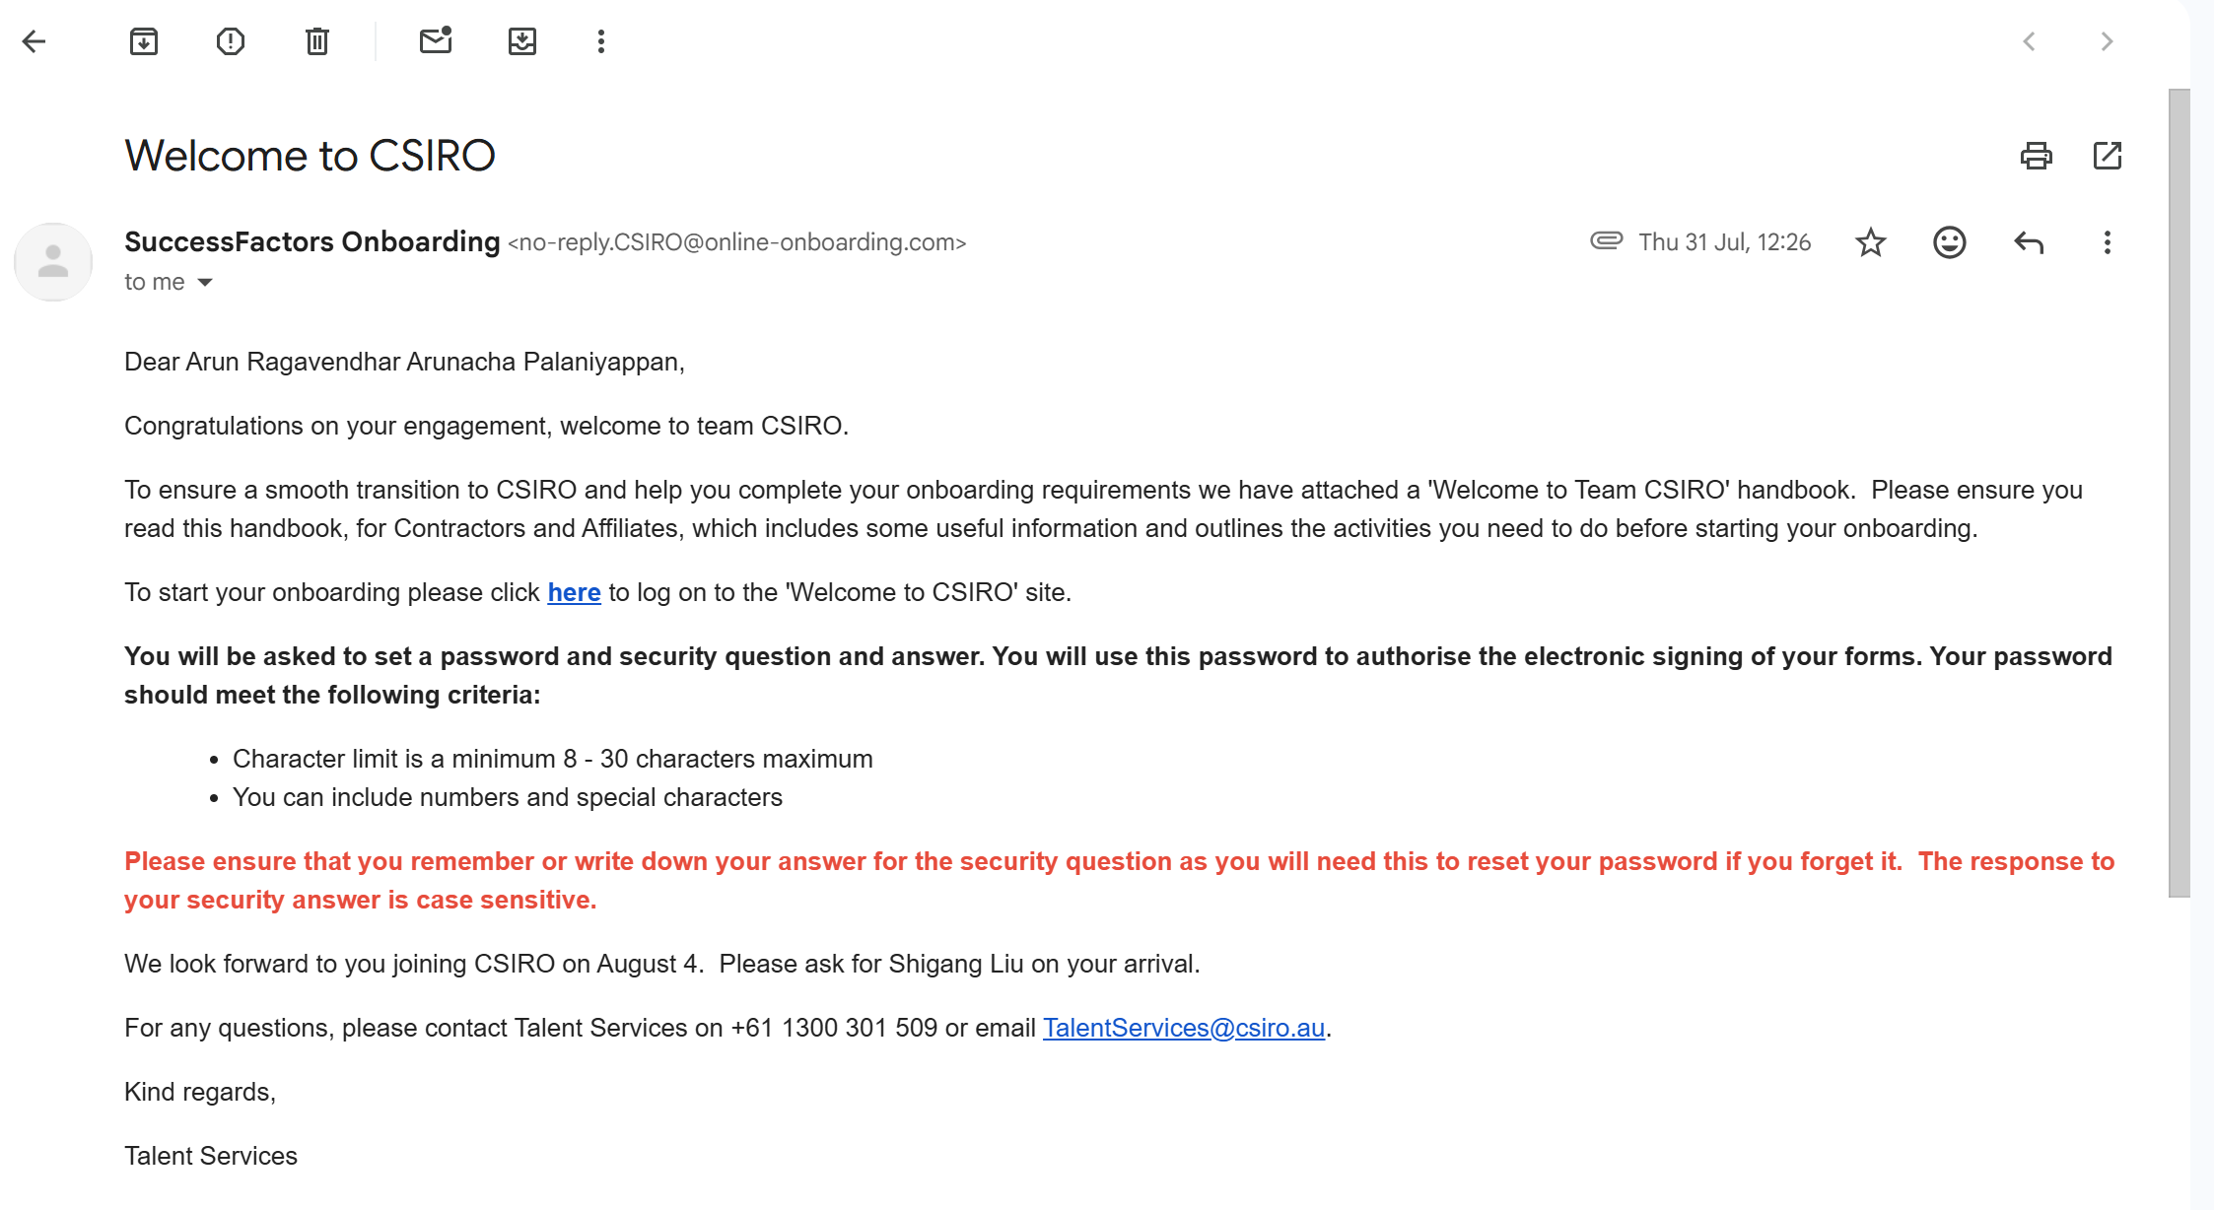
Internship offer from Focus bear
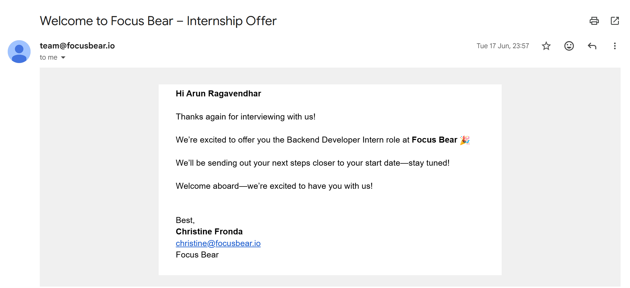

Internship Offer from Vision Verse Interactive
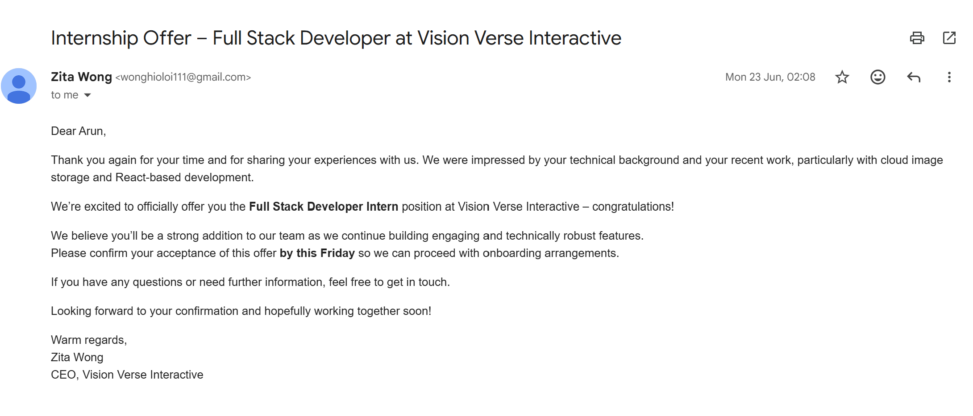

  - If you applied in only one organisation, please a brief rationale if this is not self-sourced.
This is not applicable, as I applied to three organisations through the Swinburne portal (CSIRO Data61, Focus Bear, Vision Verse Interactive).
  - What response did you provide in your interview that you think got you the offer?
In the interview, I explained about my two years of software development experience and my goal to use AI responsibly for the community, by building tools that would protect an everyday user from scams and harm. I walked through my full-stack project work and, in person at the CSIRO Clayton site, showed Dr. Shigang Liu a malware detection system I built to detect, classify, and remove malicious or corrupted files. He liked my community focus approach and the way I build with real users in mind, which I think helped me get this internship offer.

  - What would you differently in the future, when applying for a role?
Next time, I will focus even more on the impact on people and community. For each product I build, I will share a short case study, describing the problem, what I built, what changed for users, plus a quick video or link on how this can be useful for the community. I will draw on what I learned at CSIRO, which was about clearly looking at the problem, deriving a simple method with real evidence and honest limitations, and collaborating with team members in Australian work environments. I will aim for more concise updates, respectful discussions, and reliable follow-through. I will include my LinkedIn recommendation from Dr. Liu and highlight results that help everyday users. I will also state what I am still improving at (security, privacy, cleaner data) so that employers can see how I plan to grow and contribute.
- Review Forms (LO1 and LO2)
  - Complete the table below. Describe your meeting with your industry supervisor.

Meeting | When was the meeting | How long was the meeting? | Who was in the meeting?
pre-internship | 07 Aug 2025 (Week 1) | 30 Minutes | Dr. Shigang Liu, Myself (Arun)
mid-internship | 12 Sep 2025 (Week 6) | 50 Minutes | Dr. Shigang Liu (Industry Supervisor), Dr. Bita Zaferanloo (Academic Supervisor), Myself (Arun)
final internship | 24 Oct 2025 (Week 12) | 30 Minutes | Dr. Shigang Liu (Industry Supervisor), Dr. Bita Zaferanloo (Academic Supervisor), Myself (Arun)

  - Complete the table below. Apart from the technical experience, lists specific experience(s) that you said at the start of the semester you like to gain from this internship.

Experiences | Where is provided by the organisation (Y/N) | If yes, is it before or after the mid-semester visit? If no, what will you do next time to obtain it?
Practice Australian workplace habits (short updates, respectful discussion) | Yes | Before and after mid-semester (weekly check-ins with Dr. Liu)
Carry out weekly project discussion meetings with a clear agenda and minutes | Yes | Conducted each week for all 12 weeks with Dr. Liu, every Thursday morning.
Present to a mixed audience (industry + academic) | Yes | At Mid-semester(presentation) and end of semester (final review and project presentation).
Build my professional network and get supervisor feedback | Yes | Both Before and after mid-semester (meeting CSIRO colleagues, LinkedIn recommendation from Dr. Liu).
Explore community needs and gather feedback from different people in the community | No | Will try to set up a simple feedback loop (1-minute survey or quick chats, with consent) and capture 3–5 comments each iteration
Understand how the organisation works (who to involve, approvals, stakeholder roles). | Yes | Before and after mid-semester (co-ordinating joint meetings clarified roles and decision paths).

  - What would you differently in the future when meeting with team lead, supervisors, or managers?
Going forward, I will update the weekly updates with an additional one-page work plan with all the details (agenda, progress, risks, decisions, requests). In meetings, I will keep the presentation short, state what changed for users and the community, confirm attendees, record actions with owners, and send meeting minutes/notes within two hours. I will follow Australian workplace norms and bring a brief snapshot of community feedback to guide decisions.

- Communication (LO1 and LO4)
  - Complete the table below. List all other forms of communication with your industry supervisor or team.

Communication | How often is this used
Weekly email update (with tasks, evidence links, next week plan) | Weekly (Weeks 1–12)
Microsoft Teams chat (quick questions, small updates) | 2–3 times per week
Microsoft Teams video calls and meetings (weekly project progressions, check-ins, reviews) | As scheduled; more in Weeks 7–12
Calendar invites (pre/mid/final reviews) | For each meeting
OneDrive/SharePoint links (slides, code, screenshots) | Whenever sharing artefacts
Post-meeting minutes email (actions, owners, dates) | Within 2 hours after meetings
Final presentation checking and verification (with supervisor) | 1–2 sessions in Weeks 11-12
Phone call (urgent items) | Never used
GitHub Repository (complete project source code, all files and user manual | Once, at the end of the internship in week 12

  - Did you continue the weekly communication update up to week 12?
Yes, weekly updates were sent for Weeks 1–12 (evidence attached in the supporting documents section)
  - What would you differently in the future when communicating?
I will update the weekly updates and make them easy to read and act on. I will use a regular subject line and a one-sentence summary, keep one shared folder link for all files, and clearly list what decisions are needed and by when. I will use one pinned Teams thread per project, reply within one business day, and send short notes with actions and owners the same day. Each update will include a simple visual (screenshot or short clip) and written wording so non-technical readers can follow.
- Visit Scheduling (LO1, LO3 and LO4)
  - Complete the table below
Visit | Who organised it | When was the visit | Who else attended the meeting aside from you and the academic supervisor
Week 5 Clayton Site visit | My industry supervisor, Dr. Liu arranged a site visit to CSIRO clayton | 4 Sept 2025 | Industry Supervisor:  Dr. Shigang Liu (CSIRO)
Week 10  Visit at Swinburne | My industry supervisor, Dr. Liu arranged a meeting at Swinburne Library | 24 Oct 2025 | Industry Supervisor:  Dr. Shigang Liu (CSIRO)

  - What would you differently in the future when scheduling meetings?
These visits were kindly scheduled by Dr. Liu. Next time, I will take more ownership, by suggesting schedules early, sending one clear invite with agenda, goals, attendees, and a short pre-plan. For on-site meetings, I will confirm room and access at the office site and include a backup online link. After each meeting, I will send brief notes the same day with actions and dates.

- Presentation (LO2, LO3, LO4 and LO5)
  - Complete the table below. Excluding the final presentation, list all presentations have you done during the internship
Presentation | When was the presentation | Who are the audience | Who are the presenters aside from you | Where was the presentation
Weeks 1–4 project progression | 4 Sep 2025 (Week 5) | Dr. Shigang Liu | - | CSIRO Clayton site (in person)
Mid-Internship Review | 12 Sep 2025 | Dr. Shigang Liu; Dr. Bita Zaferanloo | - | Microsoft Teams (online)
FPA Code demo and walkthrough | Week 10 (mid-Oct 2025) | Dr. Shigang Liu | - | Swinburne Hawthorn Library (in person)

  - What would you differently in future presentations?
Mid-internship feedback was to shorten the presentation, avoid too much deep technical information, and show how the work done serves the community as a product. I applied this in the final review, started with the problem and who benefits, showed the result first, used one simple visual per idea, and a 1- or 2-minute demo. I will keep using this approach for future presentations and leave detailed technical points for questions from the academic and industry supervisors.

- Network (LO5)
  - Complete the table below. List all the networking events that you can attend.
Networking Events | When was the event | Who did you connect with
CSIRO Clayton site visit (progress share, Weeks 1–4) | 4 Sep 2025 | Dr. Shangqi Lai (CSIRO) and 2 fellow interns, Uugantsetseg Ochgerel and Marus Tran
“Stepping into Industry” workshop (Evolve Scientific) When was the event Who did you connect with  4 Sep 2025 Dr. Shangqi Lai (CSIRO); 3 Swinburne interns incl. Uugantsetseg Ochgerel and Marus Tran | 17 Sep 2025 | Linda Mork (Senior Recruitment Consultant)
Guest talk – Hansi Nissanka (recording viewed) | Oct 2025 | Recording viewed (no direct contact)
LinkedIn outreach during CSIRO project | Oct 2025 | Dr. Sharif Abuadbba (CSIRO Leader)

  - How many new contacts did you gained during this internship, broken down as follows

    - Fellow interns (excluding your classmates): 2 - Uugantsetseg Ochgerel and Marus Tran
    - Employees within the organisation: 2 - Dr. Shangqi Lai, Dr. Sharif Abuadbba
    - Others (external professionals): 1 - Linda Mork

  - What would you differently in the future to expand your network?
I will introduce my work with a one-minute summary focused on who it helps, ask for a short follow-up chat, and send a brief note with a demo link the same day. I will politely request, “who else should see this?”, so I can meet the right people across teams. I will log contacts and keep light-touch updates (once a month) and attend at least one CSIRO talk or brown-bag each month to meet new colleague.

- Technical Knowledge (LO3)
  - Complete the table below. List new technical topics that learned.
Technical Topics | How good would you rate your knowledge from 1 to 5
LLM prompt-injection and guardrail testing | 4
Familiar Pattern Attacks (FPA): pattern design and generators | 4
Reproducible experiments: logs, scripts, and one-file demos | 5
R for dataset checks (duplicates, near-duplicates, missing data, agreement) | 4
Memory safety in C (CWE-121) using AddressSanitizer/UBSan | 3
Python scripting for single/multi-case test generation | 5
Split-leakage checks and fair comparisons across tests | 4
Inter-model agreement basics (confusion tables, Cohen’s kappa) | 4

  - What would you differently in the future when working on similar project/role?
I will start with a small working baseline in Week 1 and write a simple test plan that says what “good” looks like. I will automate early—one script to run tests and save results—so progress is easy to check each week. I will bring in a few community voices sooner (short comments on what helps or confuses them) to keep the work practical. I will make privacy and security checks part of the routine, expand model coverage step by step, and keep results in a short, easy table. I will also maintain a one-page running note so anyone can pick up the work quickly.

Overall Reflection
This section highlights key learning points.
- List down what changes did you made in the old and new CV? How will these changes help in your job application?

- Which participation helped you the most? How will this help you in the future?

- Which participation is particularly challenging? What will you do differently in the future?

- List down what do you think is your contribution to the industry.

- List areas that you think you still need to improve on.

Supporting Documents
- CV old (the one used during the internship application)
- CV new (the one you plan to use in the future)
- Other achievements or commendation you like to share (If any)

